Lab 8 Depth and Blending

1. Create a scene with two (or more objects) placed along the z-axis, similar to the scene shown in the lecture. Remember the distance you render them at and the order you draw them will be important. For example, (as seen below) the blue triangle is drawn further along the z-axis (away from the camera) and is rendered after the red triangle. While depth testing is enabled this will render correctly.
   1. 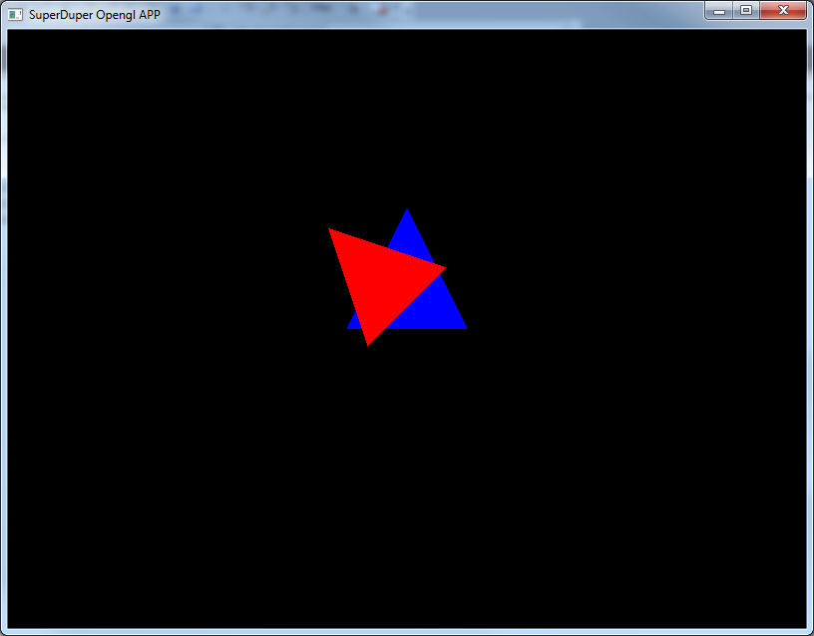
   2. Now disable depth testing, the blue triangle should render in front of the red triangle based on the render order. If nothing changes swap the render order of the triangles.
   3. With the depth testing still disabled render the cube you created several labs ago and make it rotate. The cube will have some strange effects with depth test disabled.
2. Create a transparent object, similar to that shown in the lecture. Two overlapping quads where one is transparent. Remember to setup the blend function in the scene constructor and to enable blending when rendering a shape with transparency. Set the transparent object an alpha value of 0.5f.
3. Change the constants used in the blend function and observe the differences in the final result. Consult the red book, or the link provided in the lecture for a full list of constants.
4. Create an object that resembles a pane of glass using the alpha blending technique. Make sure there are multiple objects behind the transparent object (a slight blue, quite transparent quad).
5. I have provided some textures (on Blackboard) with transparency, create some geometry textured with the transparent textures. The textures are *aTrans.png* (a large A with transparent surround) and *crateTrans.png* (a modified create texture with a whole in the middle.
6. Create a skybox as discussed in the lecture. I have provided a skybox cube mapped texture (*skybox.png)* you can use.